AICTE INTERNSHIP Task WEEK-1 :

# Firstly open the PowerBI Desktop.

# Load the Dataset in the form of a Text/CSV file.

# In the Home tab click on Transform Data and then Click on the Power Query editor.

# The power Query Editor opens with the Loaded file (Here i.e., Sustainable Supply Chain Performance).

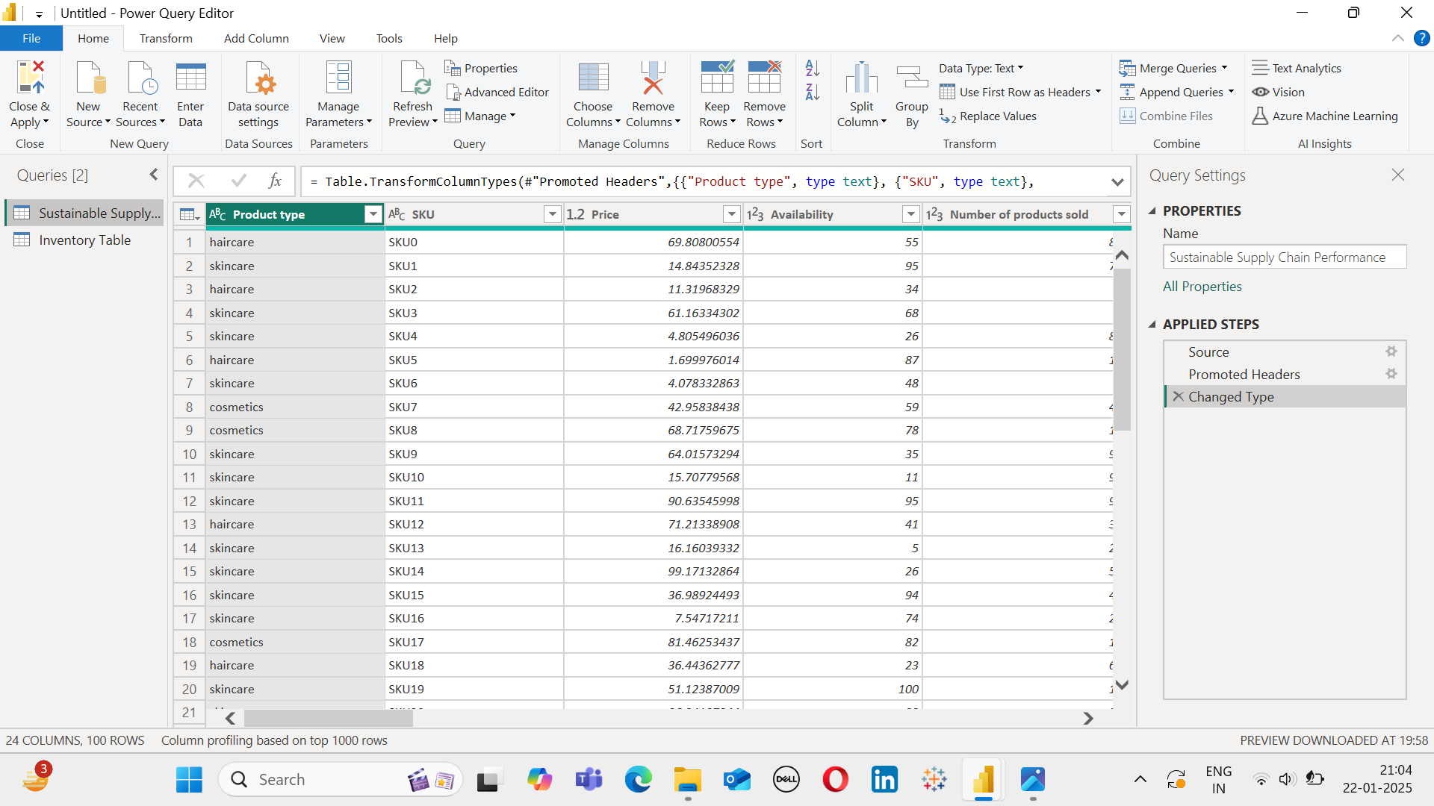

# The table appears as in the above figure.

# Now right-click on the table name on the left, from the options choose duplicate and then Rename the table.

# 

# From the given Table first create an Inventory Table with the following Attributes.This can be done by deleting the unnecessary columns from the Sustainable Supply Chain Performance Table.

# Inventory Table:

1.Product type

2.SKU

3.Availability

4.Number of Products sold

5.Customer Demographics

6.Stock Levels

7.Lead times

8.Order Quantities

9.Lead time

10.Revenue Generated

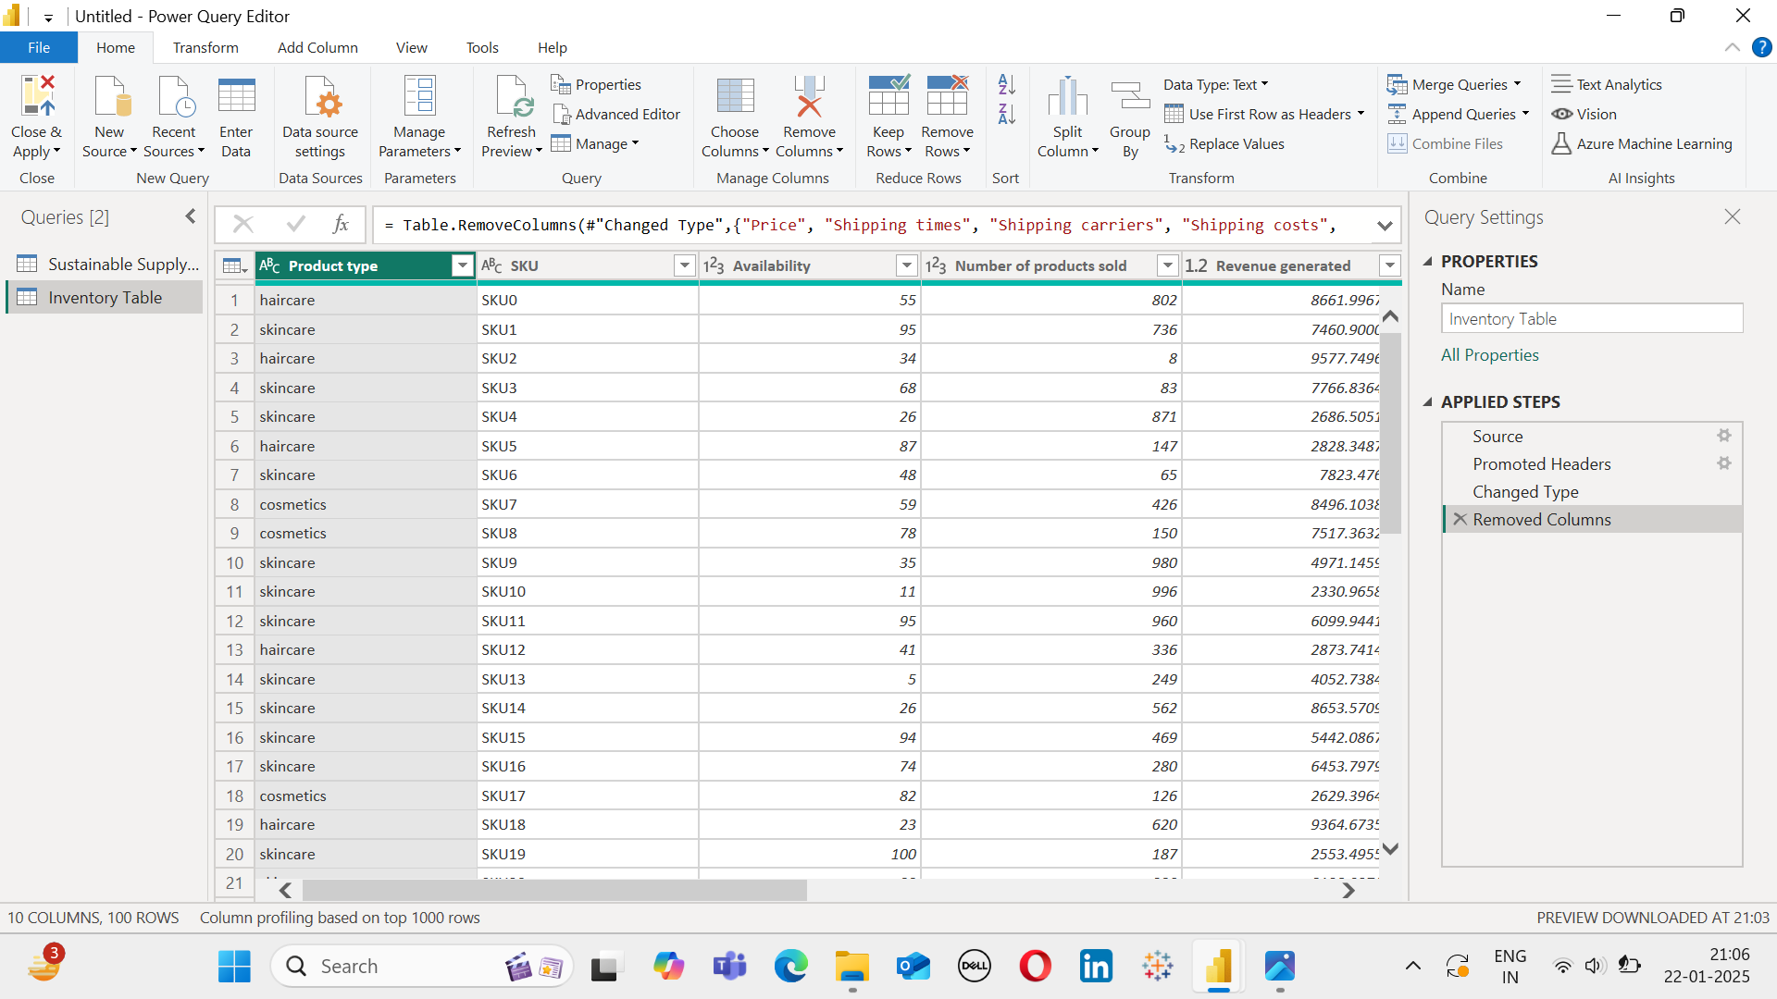

# 

# In the same way we create more tables such as manufacturing table,Supply table and Supply chain table.

# Manufacturing Table:

1.Product type

2.SKU

3.Production volumes

4.Manufacturing lead time

5.Manufacturing costs

6.Inspection results

7.Delete Rates

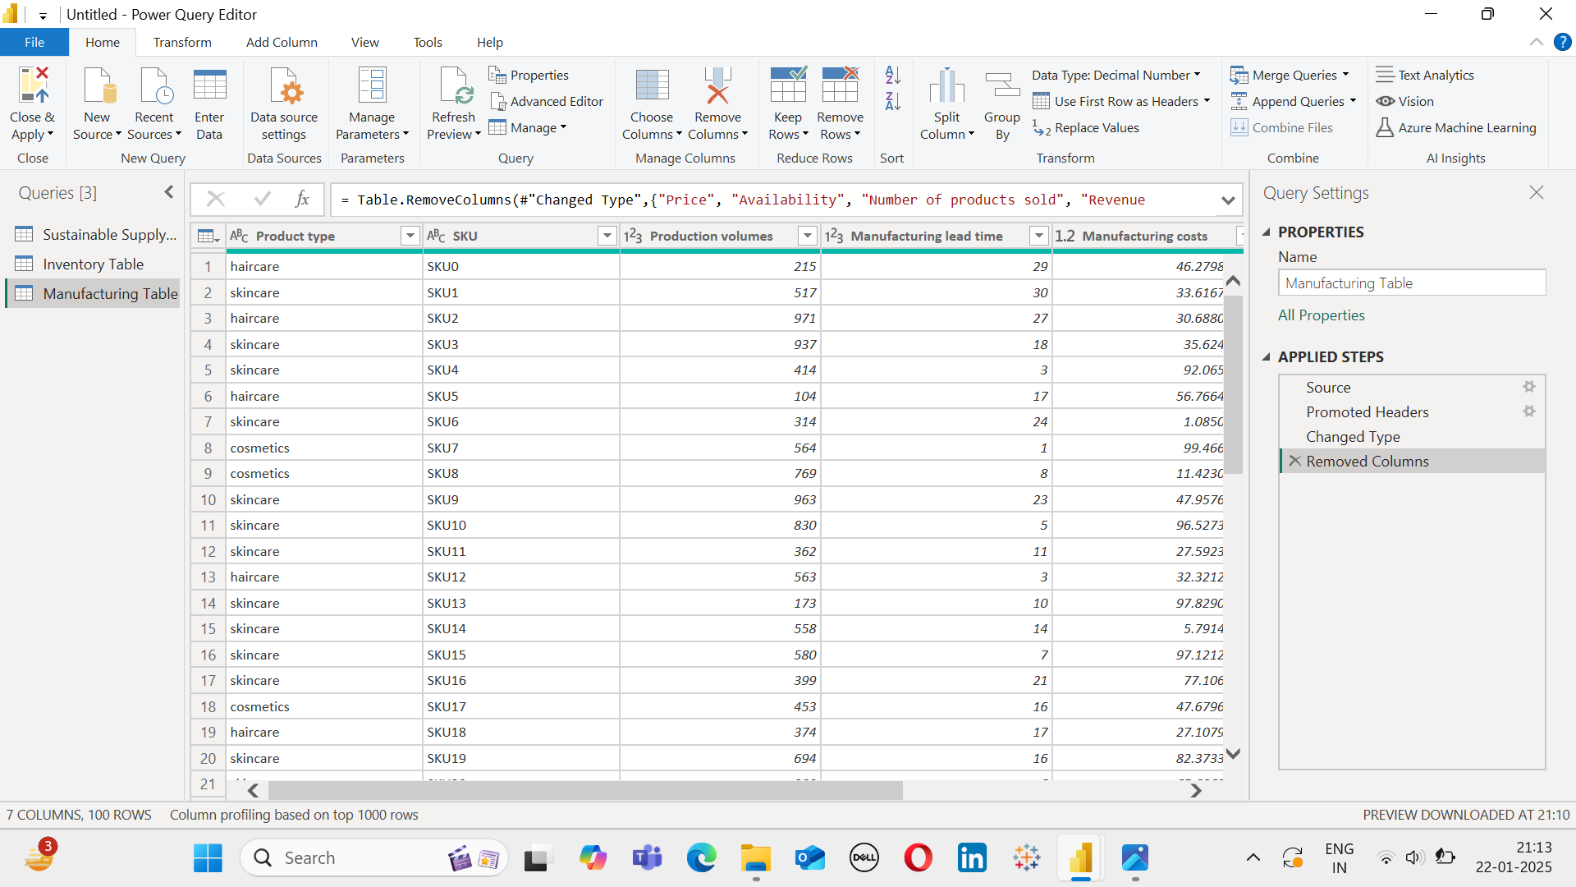

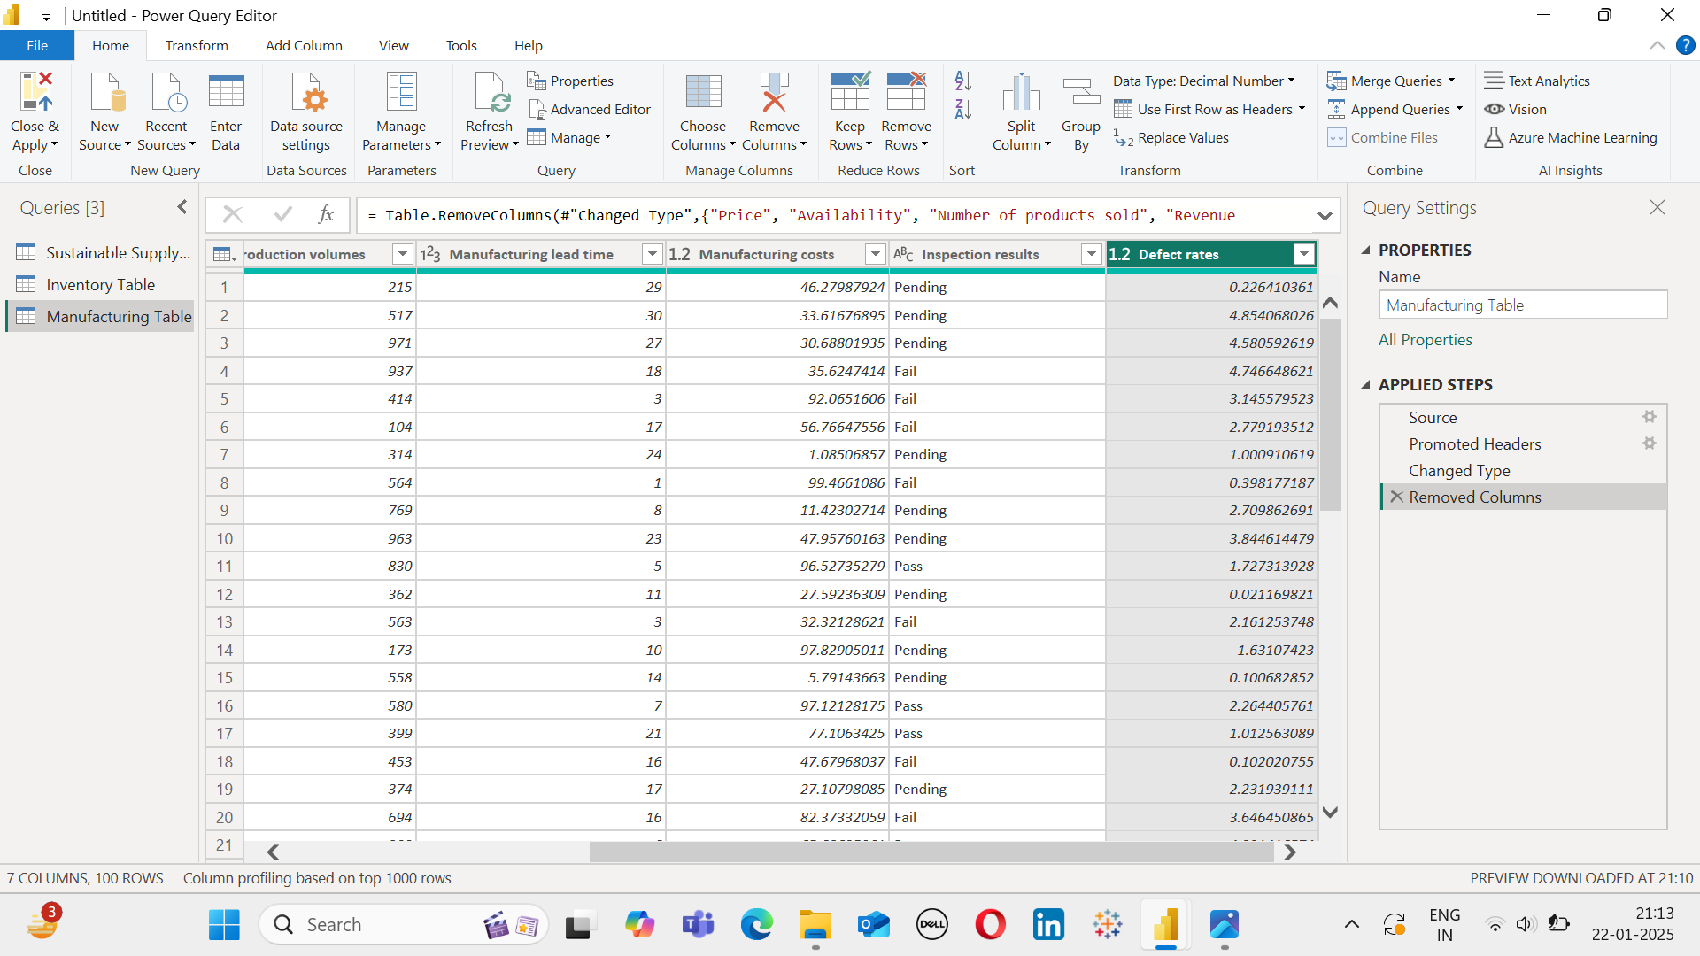

# Supplier Table:

1.Supplier Name

2.Location

3.Lead time

4.Transportation modes

5.Routes

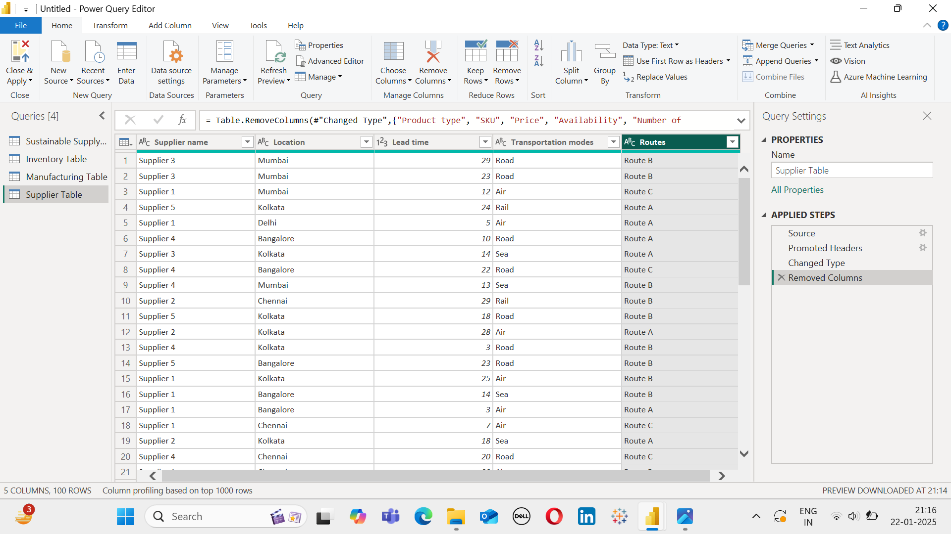

# Supplier Chain Table:

1.Product type

2.SKU

3.Price

4.Availability

5.Number of Products sold

6.Revenue generated

7.Customer Demographics

8.Stock Levels

9.Lead times

10.Order Quantities

11.Shipping times

12.Shipping carriers

13.Shipping costs

14.Supplier Name

15.Location

16.Lead time

17.Transportation modes

18.Routes

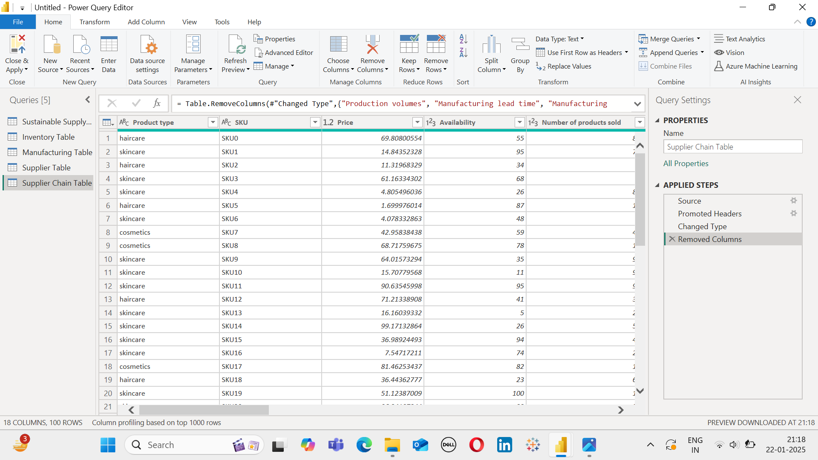

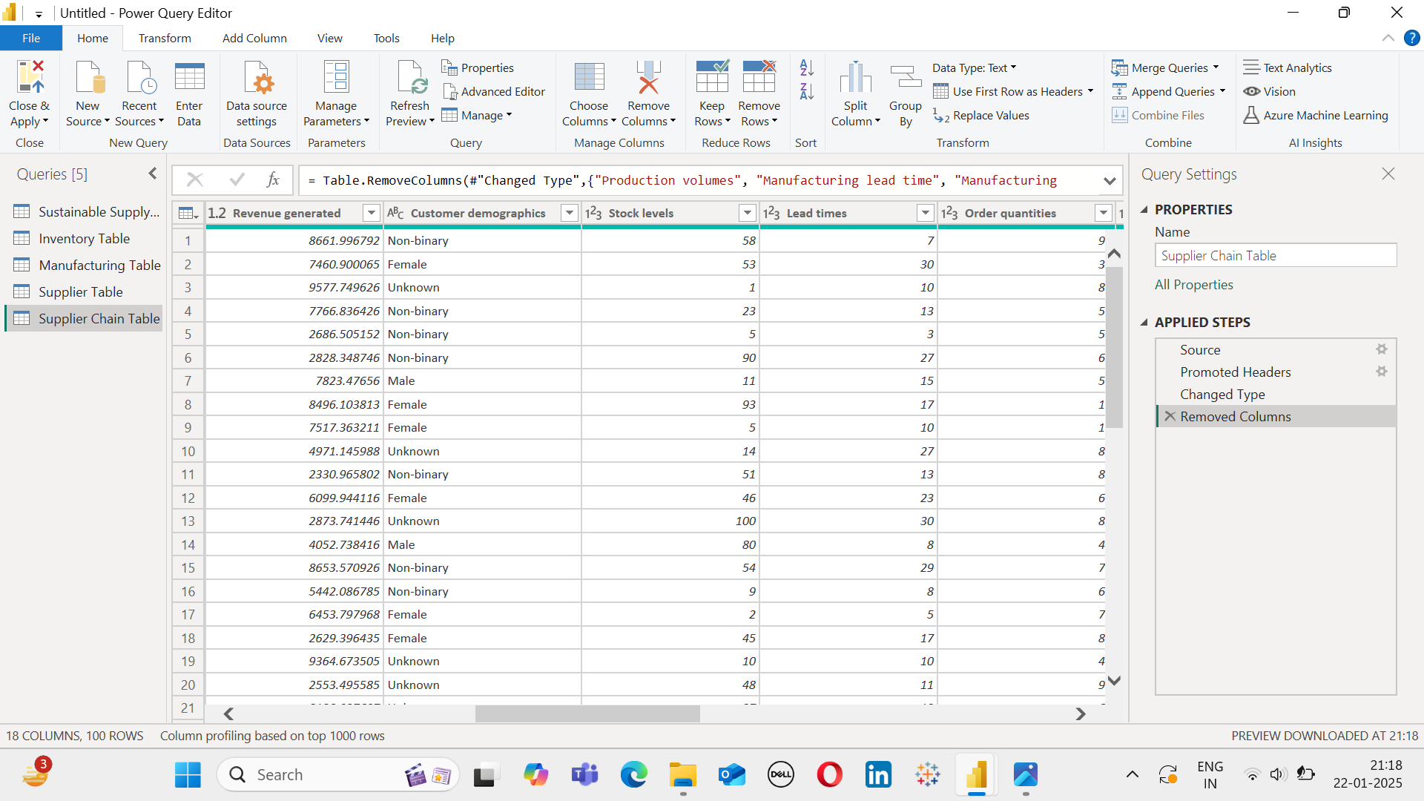

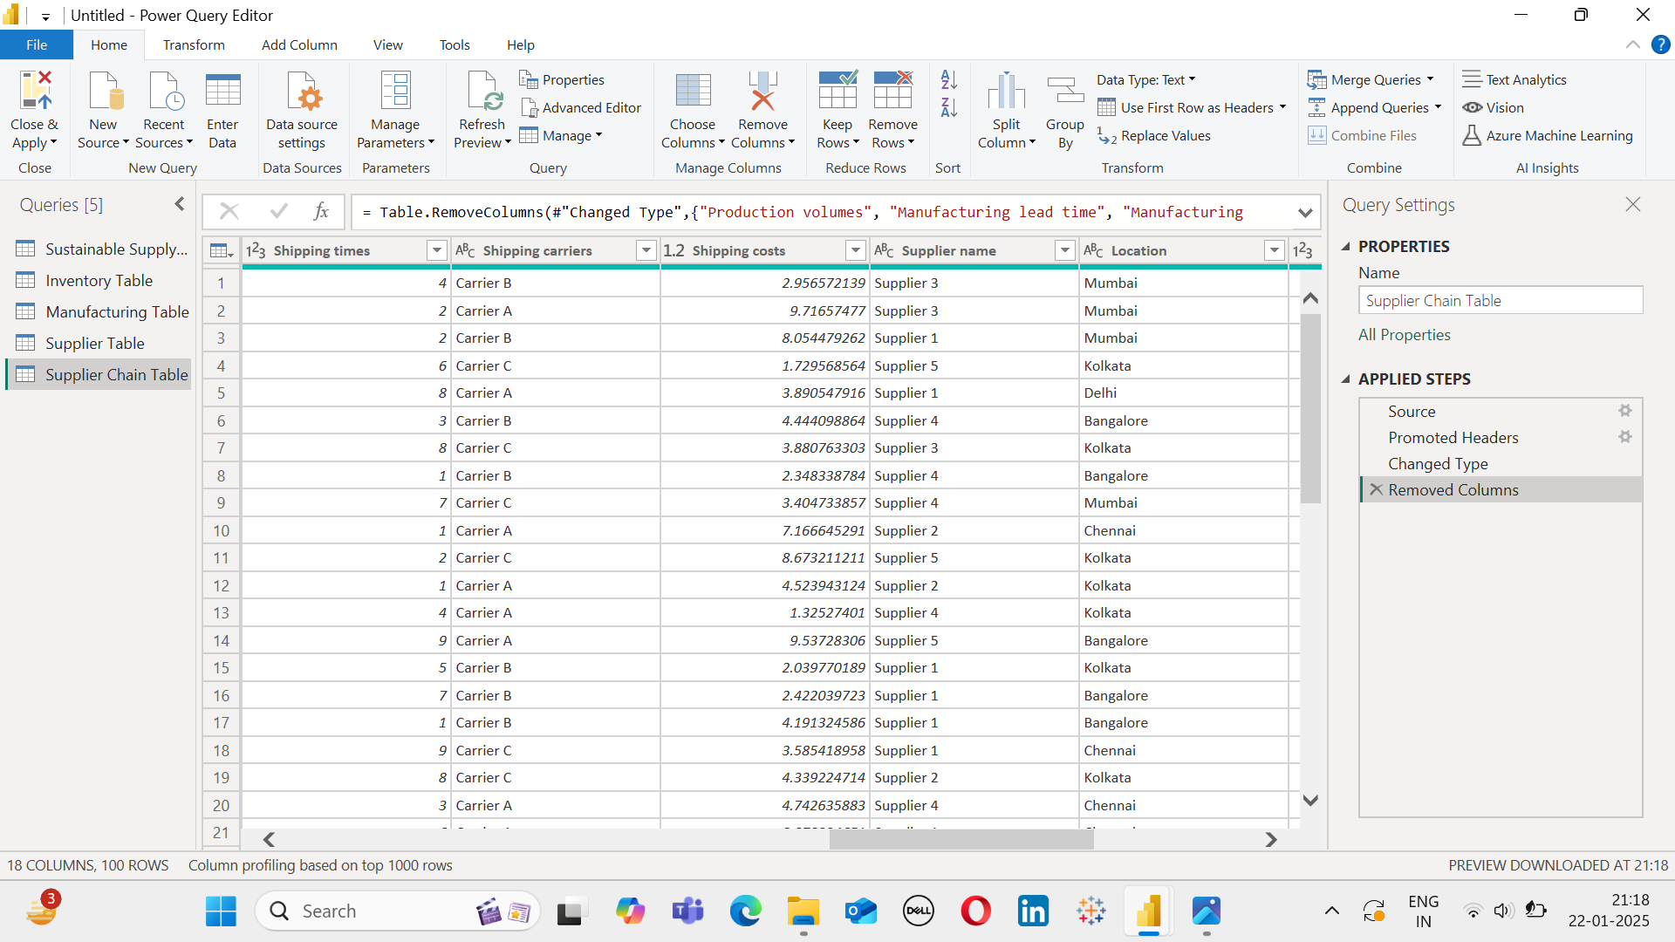

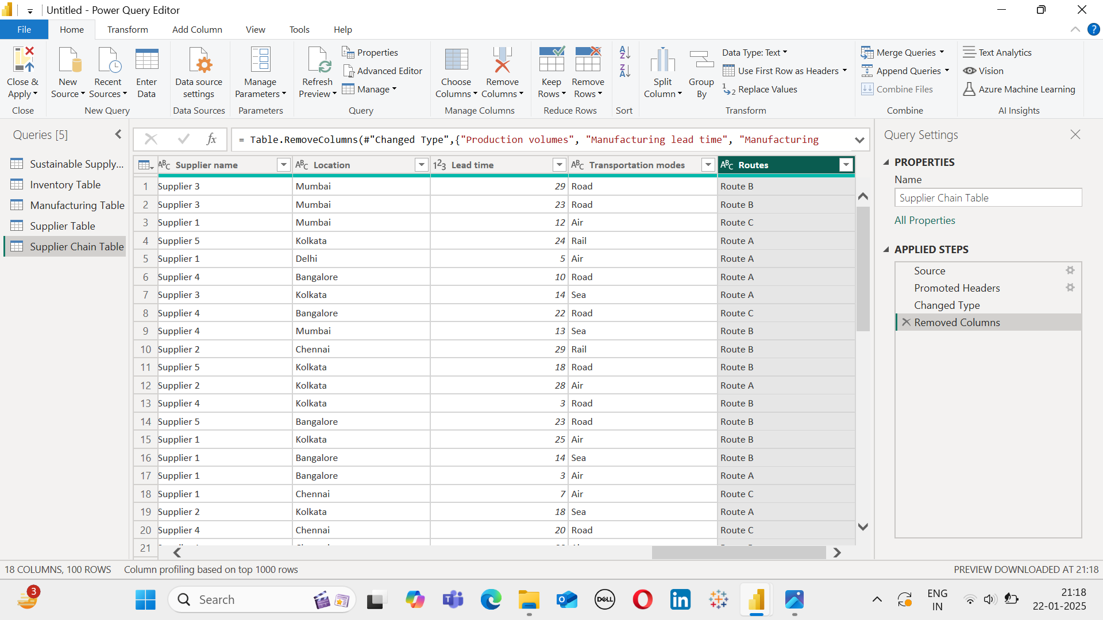

# After creating all the required tables click Close&Apply on the left

# Then you can see all the tables as below.

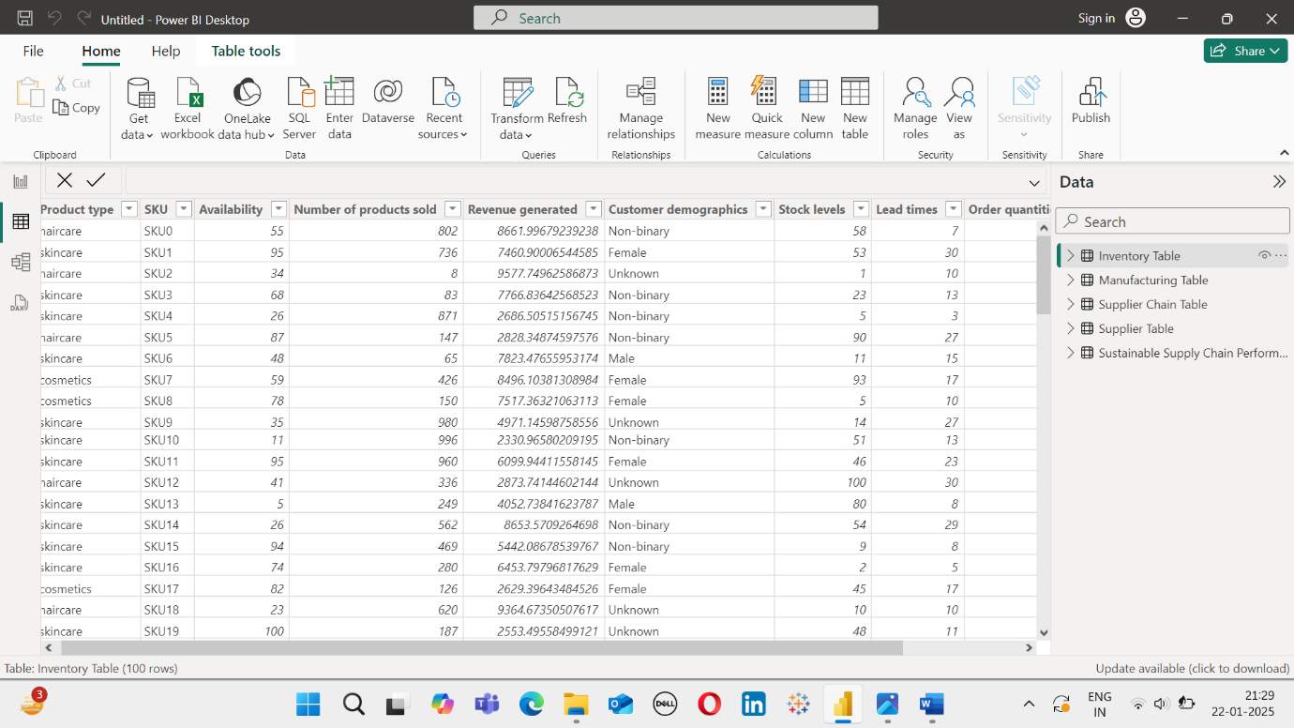

# In this way we create various tables from the existing tables making it easier for visualization.